**Convex Hull**

Find Convex Hull from a set of 2D points using Graham Scan algorithm. Given a set of points in the plane, the convex hull of the set is the smallest convex polygon that contains all the points of it.

**Pseudocode**

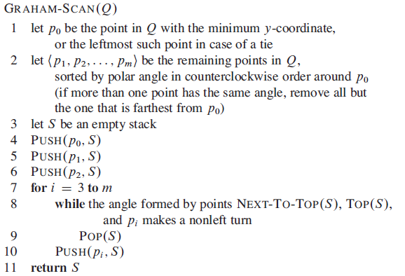

**Check orientation of three points**

<https://www.geeksforgeeks.org/orientation-3-ordered-points/>